# Ex.No:6(a) DISEASE OUTBREAK PREDICTION Date:31-Jan-2025

# Aim:-

# Predict the number of disease cases over time using historical data and basic regression models.

# Program Code:-

*import numpy as np*

import pandas as pd

import matplotlib.pyplot as plt

from sklearn.model_selection import train_test_split

from sklearn.ensemble import RandomForestRegressor

from sklearn.metrics import mean_absolute_error

*# Simulated data (this would usually be from real historical data)*

np.random.seed(42)

dates = pd.date_range('2023-01-01', periods=365, freq='D')

cases = np.random.poisson(lam=10, size=(365,))

*# Create a DataFrame*

data = pd.DataFrame({'date': dates, 'cases': cases})

*# Feature Engineering (using simple time features)*

data['day_of_year'] = data['date'].dt.dayofyear

data['month'] = data['date'].dt.month

*# Splitting the data*

X = data[['day_of_year', 'month']]

y = data['cases']

X_train, X_test, y_train, y_test = train_test_split(X, y, test_size=0.2, shuffle=False)

*# Model*

model = RandomForestRegressor(n_estimators=100)

model.fit(X_train, y_train)

*# Predictions*

y_pred = model.predict(X_test)

*# Performance*

mae = mean_absolute_error(y_test, y_pred)

print(f"Mean Absolute Error: {mae}")

*# Plot the predictions*

plt.figure(figsize=(10, 6))

plt.plot(data['date'], data['cases'], label='Actual Cases')

plt.plot(data['date'].iloc[-len(y_test):], y_pred, label='Predicted Cases', color='red')

plt.legend()

plt.title('Disease Outbreak Prediction')

plt.xlabel('Date')

plt.ylabel('Number of Cases')

plt.show()

**Output:-**



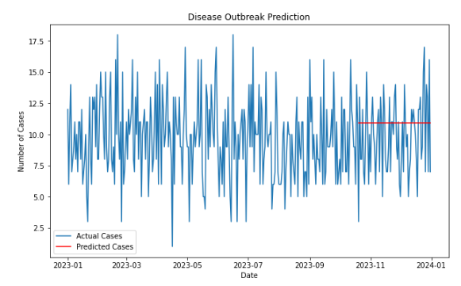

**Result:-**

The model forecassts the number of cases with an accuracy measured by Mean Absolute Error (MAE) and visualizes the predicted vs. actual cases on a time series plot.

# Ex.No:6(b) BED OCCUPANCY FORECASTING Date:31-Jan-2025

# Aim:-

# Forecast hospital bed occupancy based on historical usage patterns to aid resource planning.

# Program Code:-

import numpy as np

import pandas as pd

import matplotlib.pyplot as plt

from sklearn.model_selection import train_test_split

from sklearn.linear_model import LinearRegression

from sklearn.metrics import mean_absolute_error

*# Simulating bed occupancy data (daily occupancy between 50 and 100 beds)*

np.random.seed(42)

dates = pd.date_range('2023-01-01', periods=365, freq='D')

occupancy = np.random.randint(50, 100, size=(365,))

*# Create a DataFrame with the simulated data*

data = pd.DataFrame({'date': dates, 'occupancy': occupancy})

*# Feature Engineering (use day of year as a feature)*

data['day_of_year'] = data['date'].dt.dayofyear

*# Splitting the data into train and test sets (80% training, 20% testing)*

X = data[['day_of_year']]

y = data['occupancy']

X_train, X_test, y_train, y_test = train_test_split(X, y, test_size=0.2, shuffle=False)

*# Train a Linear Regression model*

model = LinearRegression()

model.fit(X_train, y_train)

*# Make predictions on the test data*

y_pred = model.predict(X_test)

*# Calculate the performance (Mean Absolute Error)*

mae = mean_absolute_error(y_test, y_pred)

print(f"Mean Absolute Error: {mae}")

*# Plotting the actual vs predicted bed occupancy using a bar chart*

plt.figure(figsize=(10, 6))

# Plot actual vs predicted for a specific range of dates

plt.bar(data['date'].iloc[-len(y_test):], y_test, label='Actual Occupancy', width=2, align='center', color='blue', alpha=0.6)

plt.bar(data['date'].iloc[-len(y_test):], y_pred, label='Predicted Occupancy', width=2, align='center', color='red', alpha=0.6)

plt.legend()

plt.title('Bed Occupancy Forecasting (Bar Chart)')

plt.xlabel('Date')

plt.ylabel('Bed Occupancy')

plt.xticks(rotation=45)

plt.grid(True)

plt.show()

**Output:-**



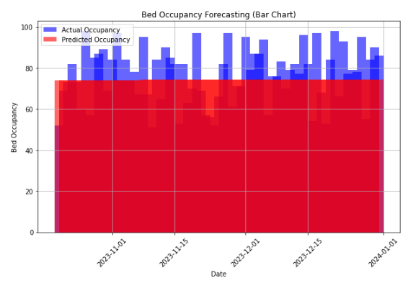

**Result:-**

The model predicts future bed occupancy, showing a comparison of actual vs. predicted values on a line plot, with performance evaluated by MAE.

# Ex.No:6(c) MEDICATION EFFECTIVENESS ANALYSIS Date:31-Jan-2025

# Aim:-

# Predict the effectiveness of medication based on treatment duration and patient demographics.

# Program Code:-

from sklearn.preprocessing import PolynomialFeatures

from sklearn.linear_model import LinearRegression

# Simulating data for medication effectiveness

np.random.seed(42)

days_treated = np.random.randint(1, 30, size=(100,))

patient_age = np.random.randint(20, 70, size=(100,))

treatment_effectiveness = 0.5 * days_treated + 0.3 * patient_age + np.random.normal(0, 5, 100)

# Create a DataFrame

data = pd.DataFrame({'days_treated': days_treated, 'patient_age': patient_age, 'effectiveness': treatment_effectiveness})

# Feature Engineering (Interaction features)

X = data[['days_treated', 'patient_age']]

y = data['effectiveness']

# Polynomial Feature Transformation for non-linearity

poly = PolynomialFeatures(degree=2)

X_poly = poly.fit_transform(X)

# Train-test split

X_train, X_test, y_train, y_test = train_test_split(X_poly, y, test_size=0.2)

# Model

model = LinearRegression()

model.fit(X_train, y_train)

# Predictions

y_pred = model.predict(X_test)

# Performance

mae = mean_absolute_error(y_test, y_pred)

print(f"Mean Absolute Error: {mae}")

# Plot the predictions

plt.figure(figsize=(10, 6))

plt.scatter(y_test, y_pred, color='blue', alpha=0.6)

plt.plot([min(y_test), max(y_test)], [min(y_test), max(y_test)], color='red', linestyle='--')

plt.title('Medication Effectiveness Prediction')

plt.xlabel('Actual Effectiveness')

plt.ylabel('Predicted Effectiveness')

plt.show()

**Output:-**



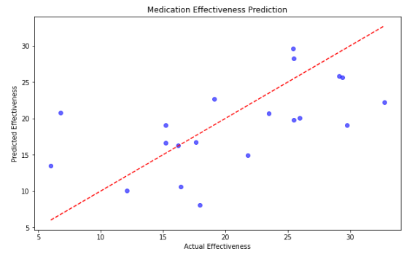

**Result:-**

The model estimates the medication's effectiveness, visualized by a scatter plot comparing actual vs. predicted effectiveness, with MAE as the evaluation metric.